**Pipeline Execution Flows -** Declarative pipeline

basic structure

pipeline {

agent { label 'GOL' }

stages {

stage('SCM'){

//step

}

}

post {

success {

}

failure {

}

}

}

* For all the steps ( Link: <https://www.jenkins.io/doc/pipeline/steps/> )
* Refer <https://github.com/asquarezone/game-of-life/commit/4bc43b410f6fd0b8418cdd071033805cda55583c> for the basic declarative pipeline to build game of life
* To the jenkinsfile we can add build triggers by using the triggers section <https://www.jenkins.io/doc/book/pipeline/syntax/#triggers> . The Jenkinsfile will be as shown below

pipeline {

agent { label 'GOL'}

triggers {

cron('H * * * *')

pollSCM('* * * * *')

}

stages {

stage('scm') {

steps {

git branch: 'master', url: 'https://github.com/asquarezone/game-of-life.git'

}

}

stage('build') {

steps {

sh 'mvn package'

}

}

}

post {

success {

archive '**/gameoflife.war'

junit '**/TEST-*.xml'

}

}

}

* Adding manual inputs from user during build refer here <https://www.jenkins.io/doc/book/pipeline/syntax/#input>

**Parameters in Jenkins**

* A Parameter is use to store a value in variable which can be used in the later build steps.
* Lets create a simple parameter in the Jenkins Freestyle project 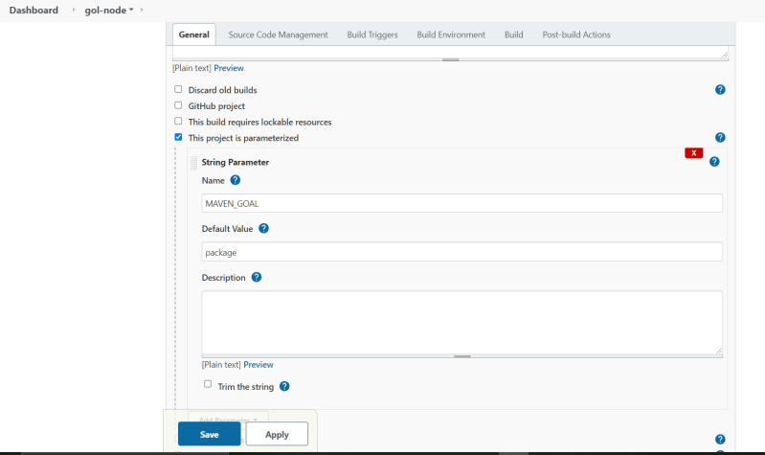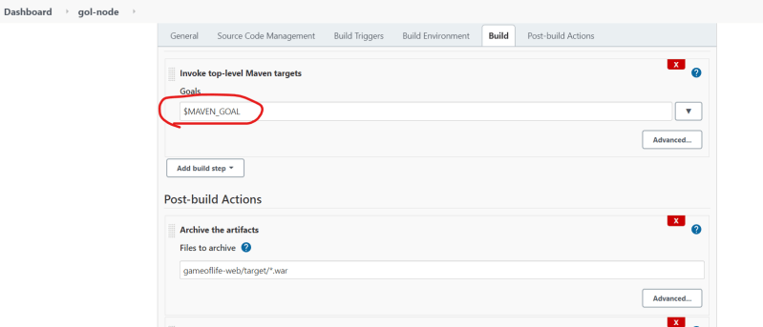
* Parameters can be created from jenkins pipelines as well <https://www.jenkins.io/doc/book/pipeline/syntax/#parameters>
* Refer here <https://github.com/asquarezone/game-of-life/commit/0ae2ffa2b1d591ba80edc4aec0cccfbe65b9ed71> for the parameters added in jenkins pipeline.
* Declarative Pipeline structure 